1. Javascript Engine

Computers only understanding 1 and 0. Computer doesn't really know what Javascript is

Javascript Engine (Like a translator) to translate your JS file to langugage that computer understand.

Today there are a lot of JS engines (Eg: V8, Tamarin, SpiderMonkey etc.)

Brendan Eich create the first JS engine (SpiderMonkey)

V8 is created using C++.

How JS engine read JS files:

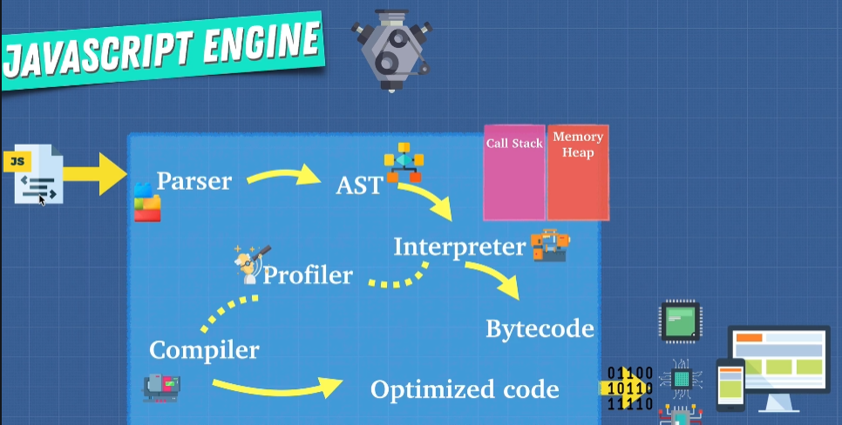

1. Give JS file, perform lexical analysis which breaks the code into tokens to identify their meaning (By Parser)
2. These tokens are formed into AST (Abstract Syntax Tree) (Can go astexplorer.net to see the demo)
3. Then it goes to Interpreter which produces code that computers understand

ECMAScript tells the standard should be followed when creating JS engine.

Two ways of translating to machine language:

1. Interpreter
   1. Read line by line
   2. JS works in this way
2. Compiler
   1. Code doesn’t get translated on the fly
   2. Read through the whole code, and try to understand what the code does, then translated into machine code/another language
   3. Lower level language usually uses this

JS can use both ways. Babel is JS compiler.

Interpreter is faster to setup and get it running. Ideal for web browsing using JS.  
Problems with interpreter is when you run a lot of JS, it can be very slow (For example looping a lot)

Compiler can do optimization. When it understands the code, it can optimize it. (For example, looping calculation of 3+3, compiler will just put it 6 rather than keep executing it)

JIT compiler (Just in Time – Combination of both) – Eg: V8 engine:

1. AST comes to Interpreter (Ignition in V8) produces bytecode
2. Profiler monitors our code as it runs and make notes how it can be optimized
3. If some same codes run a few times, it passes to compiler (Turbofan in V8)
4. As the application is still running, compiler produces optimized code which used to replace that part in bytecode

JS is an interpreted language? It depends on the implementation

Be careful of the following functions or syntax:

1. eval()
2. arguments
3. for in
4. with
5. delete (Related to hidden classes)

We should write code that is more predictable.

Web Assembly – Standard binary executable format. It can compile the code all the way down to it instead of having to go through those JS engine process.